**Purpose**

The purpose of this SOP is to describe and explain how to operate the dry bath and effectively use and maintain the machine in a laboratory setting.

**Scope of policy**

This SOP aims to instruct the user how to operate the Dry bath. This equipment should only be handled by trained personnel. Appropriate PPE should always be worn when handling/cleaning the Microfuge.

**Parameters**

Temperature range Ambient +5°C to 150°C

Temperature 0.1°C 4 digit LED display resolution Temperature ±0.2°C (at 37°C in block) uniformity Temperature ±0.3°C accuracy.

**Safety**

Do not use this product in an explosive environment.

Do not use in the presence of flammable or combustible material.

Do not heat substances that react violently when heated.

Do not touch block when hot or when unit is heating. Use block lifter.

Do not touch area around block or block well when unit is hot.

Do not spill liquids into the well area or into the unit side vent holes.

Connect unit only to a properly grounded outlet.

Ensure the correct PPE is always worn. Dispose of all waste solutions according to appropriate environmental health and safety guidelines.

**Maintenance and cleaning**

Make sure that the Corning® LSE™ Digital Dry Bath Heater and block are cool and the power cord is disconnected before performing any cleaning or maintenance.

Repair or maintenance should only be performed by an authorized service technician.

The dry bath may be cleaned with a moist cloth containing a mild soap solution. Do not immerse the dry bath in water or any liquid. The blocks may also be cleaned in a mild soapy solution. Be sure that all items have thoroughly dried before attempting to connect the cord or use the unit.

Spills: In the event liquid is accidentally spilled into the bath or well area, disconnect the plug from the outlet and turn the unit upside down to minimize liquid contact with the internal components. Remove the bottom cover and inspect to assure liquid has not contacted heater elements, electronic controls, or connectors. Have a qualified service technician clean the unit and replace any damaged parts

**Operation**

1. Press the Temperature Up or Down keys to adjust to the desired temperature.

2. Press the Timer Up or Down keys to adjust to the desired time.

3. Press the Start/Stop key to start heating.

4. If you need to reset the timer during heating, press the Start/Stop key to deactivate heating.

5. Press the Start/Stop key again to stop the unit.

6. If the lid is to be used, align the shaded area on the dry bath surface with the magnet of the lid to attach it to the housing. To remove the lid, press one hand firmly on the housing and use the other hand to pull the lid off. To use the lid, the tube should not exceed 25 mm above the heating block.

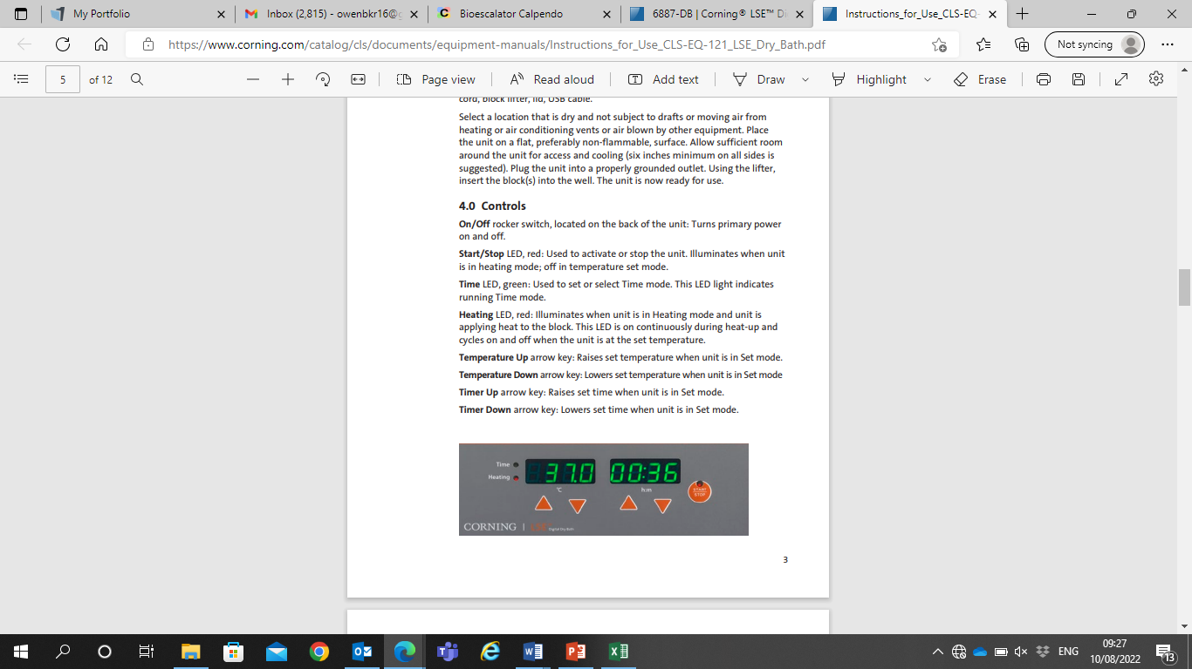

On/Off rocker switch, located on the back of the unit: Turns primary power on and off. Start/Stop LED, red: Used to activate or stop the unit. Illuminates when unit is in heating mode; off in temperature set mode. Time LED, green: Used to set or select Time mode. This LED light indicates running Time mode. Heating LED, red: Illuminates when unit is in Heating mode and unit is applying heat to the block. This LED is on continuously during heat-up and cycles on and off when the unit is at the set temperature. Temperature Up arrow key: Raises set temperature when unit is in Set mode. Temperature Down arrow key: Lowers set temperature when unit is in Set mode Timer Up arrow key: Raises set time when unit is in Set mode. Timer Down arrow key: Lowers set time when unit is in Set mode

**Errors/troubleshooting**

|  |  |  |
| --- | --- | --- |
| **Problem Solution** | | |
| Display/LEDs do not light up | 1. Check power cord and outlet.  2. Check On/Off switch.  3. Check fuse.  4. Contact Corning Life Sciences for service | |
| Unit not heating | 1. Is set point below room temperature?  2. Is “Start” LED illuminated?  3. Press “Start” key.  4. Contact Corning Life Sciences for service | |
| Unit display overshoots | 1. Normal operation. Display set point in heat-up overshoots on initial heat-up but block and sample do not overshoot (see Operation section) |
| Block or sample temperature not the same as display | 1.Is unit in heating mode  2. Is unit sitting in a drafty area? temperature  3. Check accuracy of thermometer.  4. Is thermometer making good contact?  5. Follow calibration procedure |