**Purpose**

The purpose of this SOP is to ensure the user has a basic understanding on how best to safely operate the water bath. This equipment should only be operated by trained personnel.

**Scope of policy**This SOP will include how to operate the water bath in the safest way possible, how to maintain and clean the water bath on a regular basis, and important safety information to consider when using the water bath.

**Introduction**

**Safety Information**

Grant water baths meet the requirements of international safety standard IEC 61010 – “Safety requirements for electrical equipment for measurement, control, and laboratory use”. They also comply with the equivalent national standards including EN 61010-2-010 UL 61010A-2-010 CAN/CSA-C22.2 NO. 61010-2-010-04.

Surfaces and water can be hot during and after use. Before emptying a bath, allow the water temperature to fall to a safe level. For 12, 18, 26, dual & 34 litre baths, empty the bath before moving it.

This bath is only intended for use with water. Use of other fluids may invalidate warranty and present a risk of fire or explosion. Place on a stable flat surface to reduce the risk of accidental spillage. No user serviceable parts.

Risk of electric shock after disassembly or operation with covers removed. Not for use in environments with a risk of flammable or explosive gases. To be operated within the limits listed in this guide Only use the mains cord provided or one with an identical rating.

Ensure that the mains plug and the switch are easily accessible.

A clearance of >10cm around the bath is required to ensure adequate air flow.

If a potentially hazardous liquid is spilt onto the equipment, disconnect it from the power supply and have it checked by a competent person.

It is the user’s responsibility to carry out appropriate decontamination if hazardous material is spilt on the equipment. Clean the outside of the equipment with a damp cloth, using water and domestic cleaning products only.

The use of other chemical cleaning agents may damage the equipment. Always follow the manufacturer’s instructions and any applicable legislation about the use of potentially hazardous substances. JB Academy, JB Nova and SUB Aqua Pro 31394 V1 Detailed operating manual Page 7 www.grantinstruments.com To preserve your water bath in peak condition consult the extra guidance listed below. Failure to do so may affect your warranty. Consult online resources for additional important information.

For optimum performance prevent tray from touching bath sides. Before first switching on the bath please remember to fill the bath with water. Switching the bath on dry can damage the heater and could invalidate the product warranty.

If the equipment has been transported or stored in cold or humid conditions, condensation may form inside it. If that could have happened, allow time (at least 2 hours at room temperature) for the condensation to evaporate before using the equipment.

**Operation**

Operation above 60°C The lid must be used above 60°C to maintain proper temperature control and to ensure that the water temperature reaches the set point.

The lid will also prevent excessive evaporation that requires the bath to be filled more often and will save energy.

Flat bottomed vessels-Do not place flat-bottomed vessels or other objects directly on the bottom of the tank. Always use the base tray. This avoids possible damage to the heater mounted under the tank. The base tray also improves temperature control

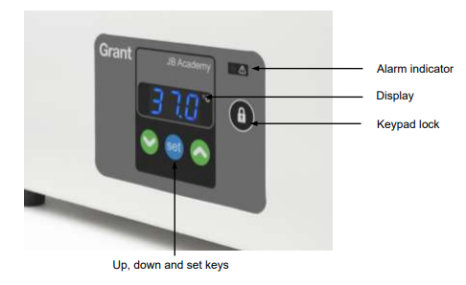

There are two indicators: • Main display – used to show temperature and short messages • Warning (red when lit). Marked

The water temperature of the bath can be set using the main display. The following example shows setting the water bath to 37.0°C. Note that once the set point is entered the bath shows a scrolling bar display indicating the bath is heating. Once the bath is with 1°C of the set temperature this will change to displaying the actual water temperature in the bath.

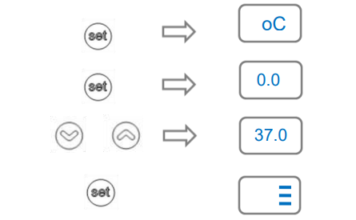

Enabling the keypad lock The keypad lock is intended to help users avoid accidental changes to the set point temperature of the bath. To enable and disable the lock, press and hold the lock and up or down keys for three seconds as shown below

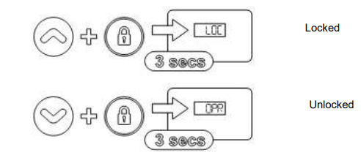

**Maintenance**

Cleaning:

Clean the outside of the equipment with a damp cloth. Domestic detergents may be used to remove stubborn dirt. Scale on immersed parts can be removed using chemical de-scaling products designed for use on kitchen equipment that have metal parts. Descaling products may be toxic and manufacturer’s instructions should always be followed. Before using any other cleaning or decontamination method, check with Grant Instruments or your local representative to make sure that the proposed method will not damage the equipment.

TURN OFF THE WATER BATH FIRST.

* Empty the water bath using the outlet on the front panel.
* When the water bath is empty rinse it out with deionised water and spray it with disinfectant (chemgene) followed by 70% ethanol (make sure you also clean the tray inside in the same way).
* After spray the water bath with ethanol, allow it to evaporate.
* Add aquagaurd to the clean new water to fill the water bath. (2ml per litre of water)
* Add the water into the water bath.
* Turn the water bath back on and allow it to reach it set temperature.