**Purpose**

The purpose of this SOP is to describe how the PH Meter should be operated and managed correctly to ensure safe and sufficient use.

**Scope of policy**

The scope of this SOP is for the changing of PH electrode solution (KCL) and maintaining the PH meter and targets any person who has used or intends to use such equipment. These facilities are designated for laboratory workers and any persons working in a laboratory.

**Introduction**

**Warnings**

Take care when handling chemical agents. These many contain irritant, corrosive or toxic ingredients. Wear protective gloves and goggles and a lab coat when operating the machine.

**Ph meter maintenance**

When not in use the pH electrode is stored in pH electrode solution (KCL) (see COSHH **0004**).  The electrode should never be left dry and uncovered otherwise it will damage the probe.

• Make sure pH electrodes are always kept filled with the appropriate filling solution

• For maximum accuracy, any filling solution that may have crystallized and encrusted the outside of the electrode should be removed with deionized water.

• Always store the electrode according to the manufacturer’s instructions and do not allow it to dry out.

If the electrode slope falls rapidly, or if the response becomes sluggish, the following procedures may help. Try one of the following, depending on your sample. Run a new calibration after treatment

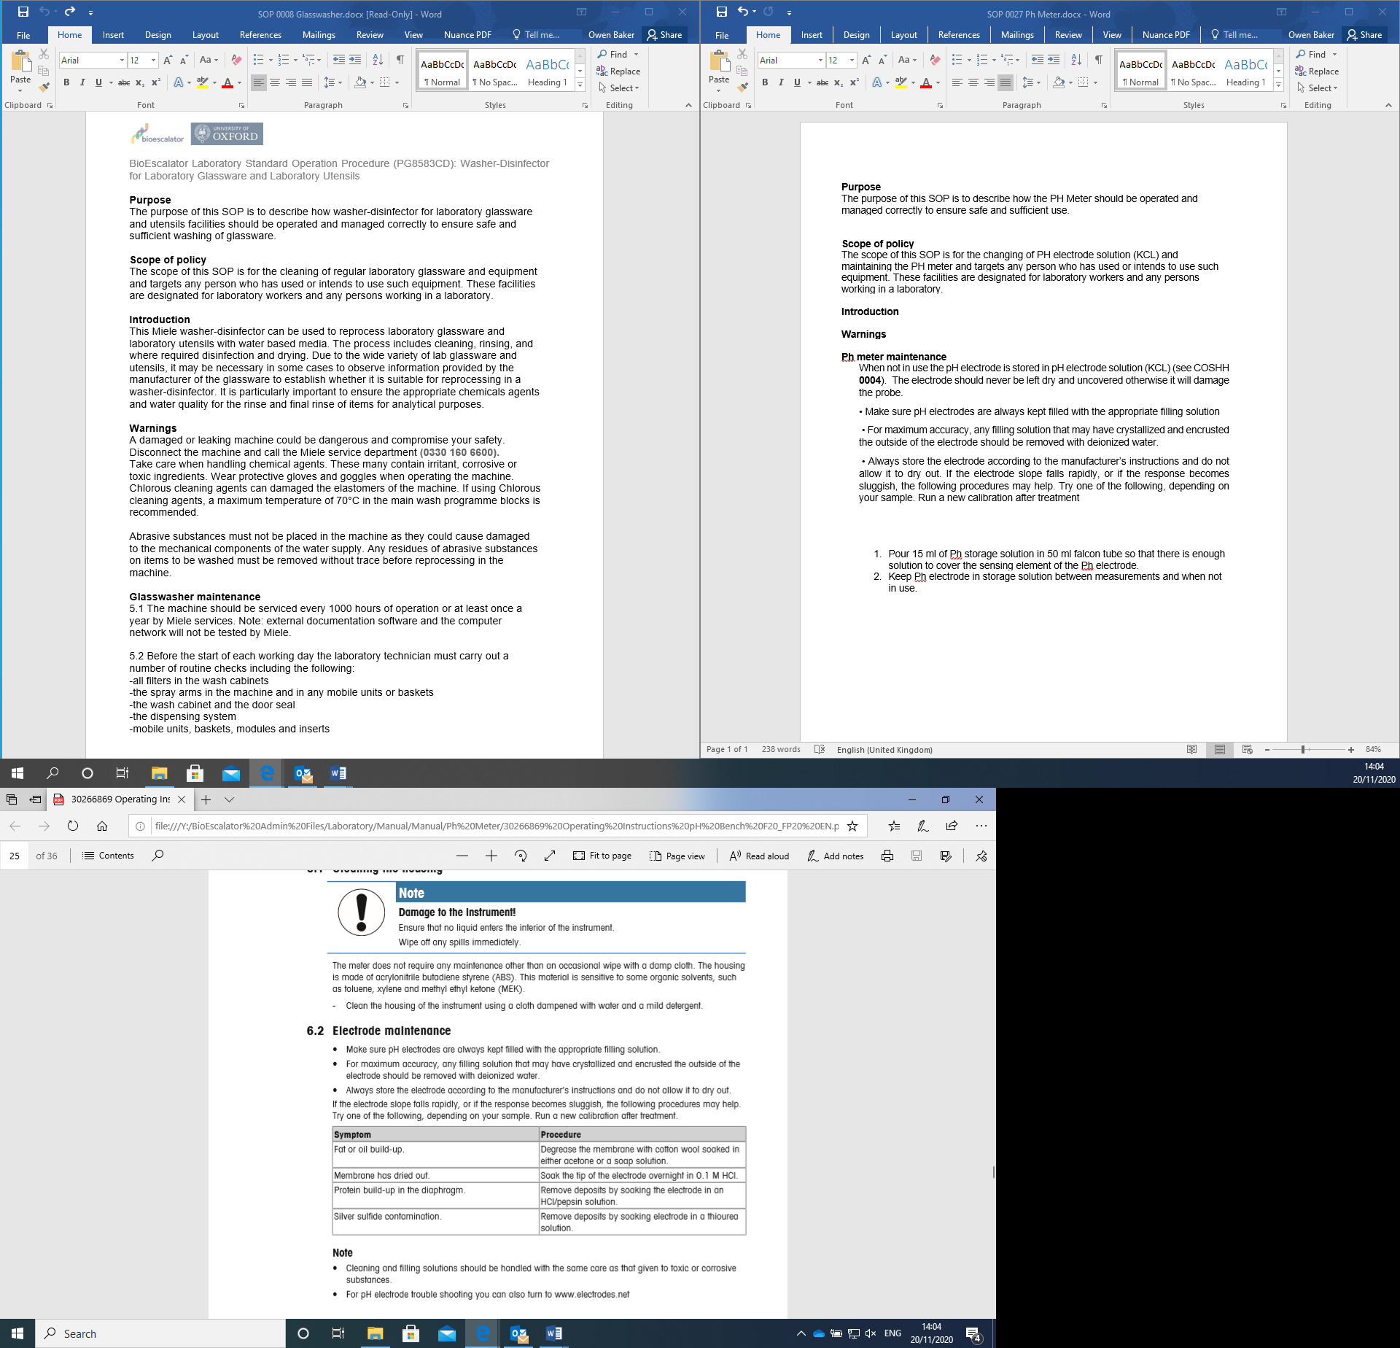

1. 15 ml of Ph storage solution in 50 ml falcon tube so that there is enough solution to cover the sensing element of the Ph electrode.
2. Keep Ph electrode in storage solution between measurements and when not in use.

**Problem solving guide**

|  |  |  |
| --- | --- | --- |
| **Error** | **Description** | **Resolution** |
| Err1 | Memory access error | Reset to factory settings |
| Err2 | Self-diagnosis failed | Repeat the self-diagnosis procedure and make sure that you finish pressing all five keys within 2 minutes. |
| Err3 | Measure values out of range | Make sure that the electrode wetting cap has been removed and the electrode is properly connected and places in the sample solution. If no electrode connected, pit the shorting plug on the socket. |
| Err4 | Calibration buffer temperature out of range (5 to 40⁰ C ) | Keep the temperature within the range for calibration ( 5 to 40⁰c) |
| Err5 | Offset out of range | Make sure you have the correct buffer and that it is fresh. Disconnect, clean and/or replace the electrode. |
| Err6 | Slope out of range | Make sure you have the correct buffer and that it is fresh. Disconnect, clean and/or replace. |
| Err7 | Meter cannot recognize the buffer (wrong buffer) | Make sure you have the correct buffer and that it is fresh. Disconnect, clean and/or replace. |
| Err8 | Memory is full | Clear the memory |
| Err9 | Measurement data cannot be stored twice |  |