**Purpose**

The purpose of this SOP is to describe how washer-disinfector for laboratory glassware and utensils facilities should be operated and managed correctly to ensure safe and sufficient washing of glassware.

**Scope of policy**

The scope of this SOP is for the cleaning of regular laboratory glassware and equipment and targets any person who has used or intends to use such equipment. These facilities are designated for laboratory workers and any persons working in a laboratory.

**Introduction**

This Miele washer-disinfector can be used to reprocess laboratory glassware and laboratory utensils with water based media. The process includes cleaning, rinsing, and where required disinfection and drying. Due to the wide variety of lab glassware and utensils, it may be necessary in some cases to observe information provided by the manufacturer of the glassware to establish whether it is suitable for reprocessing in a washer-disinfector. It is particularly important to ensure the appropriate chemicals agents and water quality for the rinse and final rinse of items for analytical purposes.

**Warnings**

A damaged or leaking machine could be dangerous and compromise your safety. Disconnect the machine and call the Miele service department **(0330 160 6600).**

Take care when handling chemical agents. These many contain irritant, corrosive or toxic ingredients. Wear protective gloves and goggles when operating the machine.

Chlorous cleaning agents can damaged the elastomers of the machine. If using Chlorous cleaning agents, a maximum temperature of 70°C in the main wash programme blocks is recommended.

Abrasive substances must not be placed in the machine as they could cause damaged to the mechanical components of the water supply. Any residues of abrasive substances on items to be washed must be removed without trace before reprocessing in the machine.

**Glasswasher maintenance**

5.1 The machine should be serviced every 1000 hours of operation or at least once a year by Miele services. Note: external documentation software and the computer network will not be tested by Miele.

5.2 Before the start of each working day the laboratory technician must carry out a number of routine checks including the following:

-all filters in the wash cabinets

-the spray arms in the machine and in any mobile units or baskets

-the wash cabinet and the door seal

-the dispensing system

-mobile units, baskets, modules and inserts

5.3 Cleaning: clean the control panel with a damp wet cloth and a little washing-up liquid, wipe the door with a damp cloth and regularly clean the groove in the plinth panel under the door with a damp cloth. The wash cabinet is largely self-cleaning however if deposits start to build up, contact Miele services (0330 160 6600).

5.4 Mobile units, baskets, modules and inserts should be checked daily to make sure they are functioning correctly. Check the following points:

-are all mobile units, baskets, modules and inserts securely attached and undamaged

-make sure all spray arms move freely

-make sure the magnets integrated into the spray arms have no metallic objects sticking to them.

5.5 The air filter for the internal drying unit has limited lifespan and has to be replaced and regular intervals, e.g. when the display screen reads ‘Change HEPA filter’. If possible the HEPA filter should be changed by Miele during a service. If this is not possible it should be done by a lab technician or manager.

5.6 Clean the filters once a week. Wearing gloves and looking out for any glass, remember to look for any fraying metal or that might cut you. Take out the sump filters by squeezing the top remove any substances on the filter with a sponge and wash out with water.

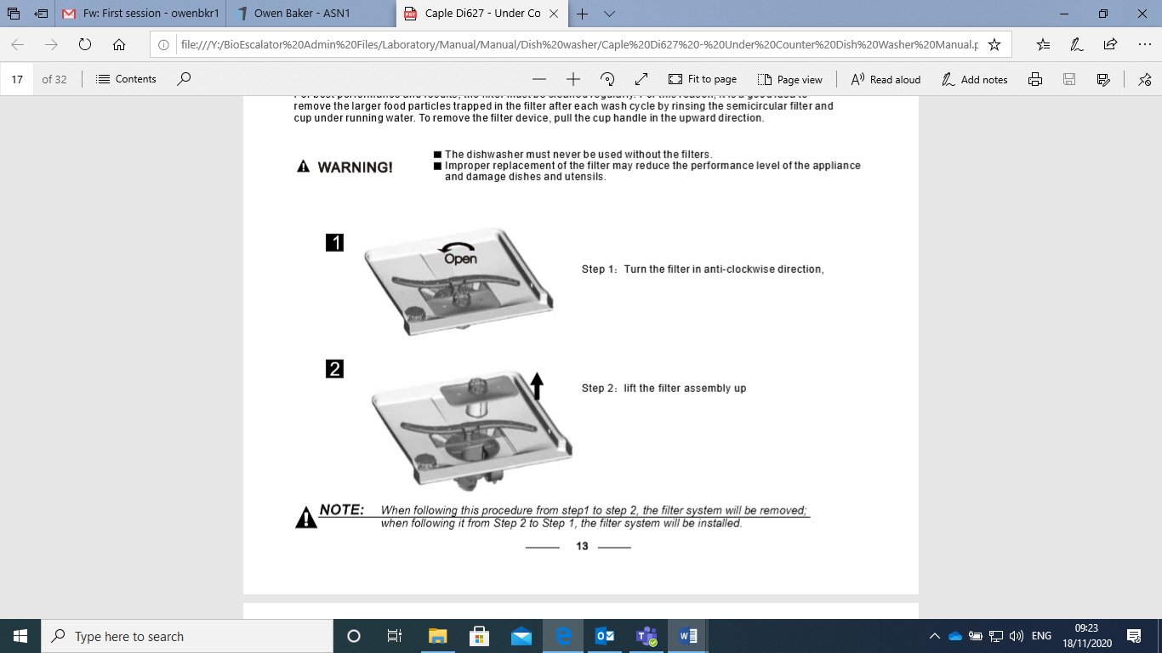

**Problem solving guide**

|  |  |
| --- | --- |
| The display is dark and all LEDs are out | The machine is not switched on.  A fuse is defective or has tripped  The machine is not plugged in |
| The machine has switched itself off | This is not a fault. The auto-off function switches the machine off automatically after a pre-set duration to save energy.  Turn the machine on. |
| The time appears on the display | This is not a fault  The machine is ready for use  Press any button to reactivate the machine |
| Interruption to the power supply during operation | If a temporary interruption to the power supply occurs during a programme sequence, no action is required. The programme will continue after the interruption.  Each interruption to the power supply is reported in the process documentation. |
| Display screen reads ‘next service due on’ | This is not a fault.  Miele Service has recommended a date for the next service visit.  Contact the services to arrange a visit. |
| Display screen reads ‘DOS refill’ | During a programme sequence a low level of liquid chemical agent in a container has been identified.  Replace the empty container with a full one. |
| Display screen reads ‘venting DOS cancelled. Venting must be repeated’ | Venting of the dispensing system was cancelled because an insufficient flow rate was identified. A dispensing hose may be kinked or a siphon blocked.  Check the dispensing hose for kinks and leaks. Position it so that it cannot become kinked. Check the suction aperture of the siphon for blockages and remove these as necessary.  Start the venting process again. |